1. What is JQuery ?

Ans JQuery is a javaScript library

JQuery is easy to learn

JQuery is simpli

1. How to apply CSS using JQuery, How to add class and remove class in jquery, JQuery animation?

Ans add CSS

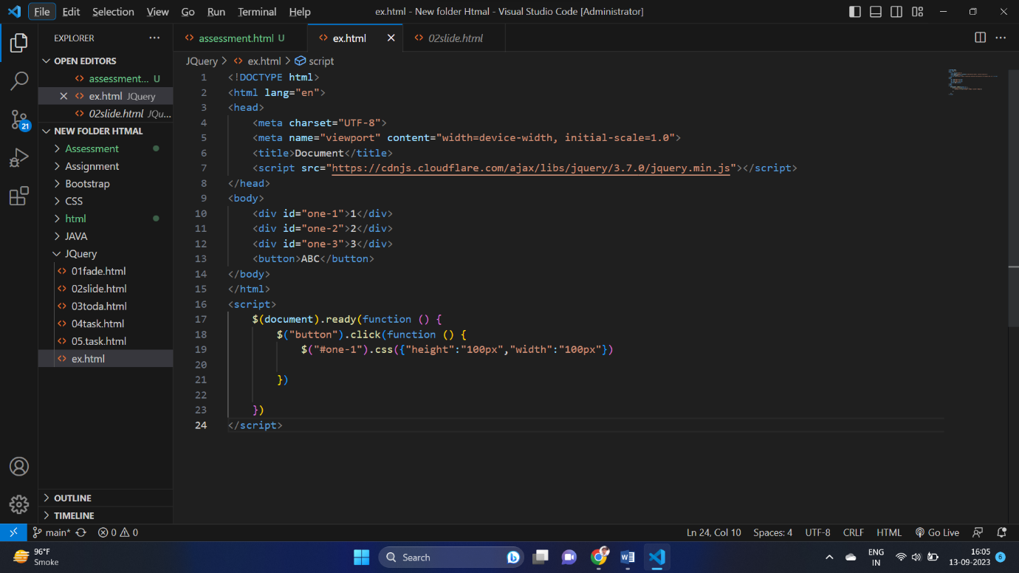

Add class

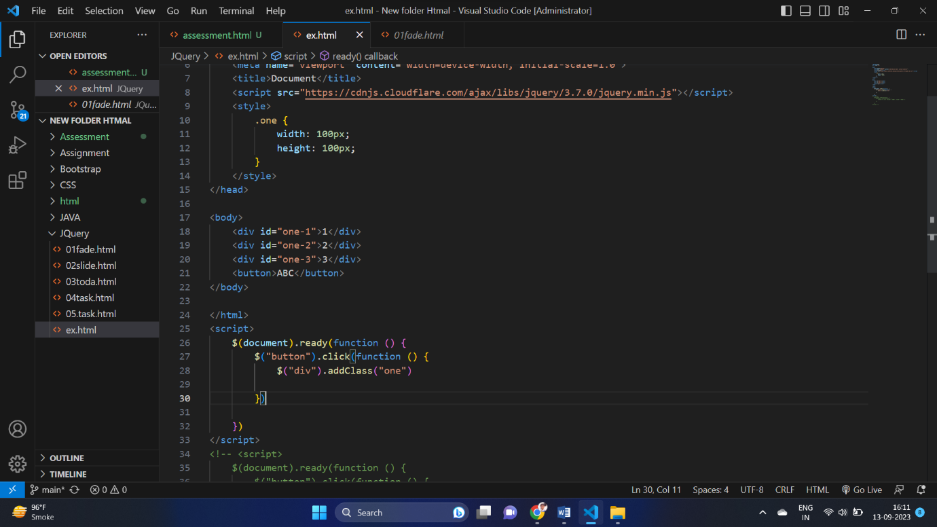

Remove class

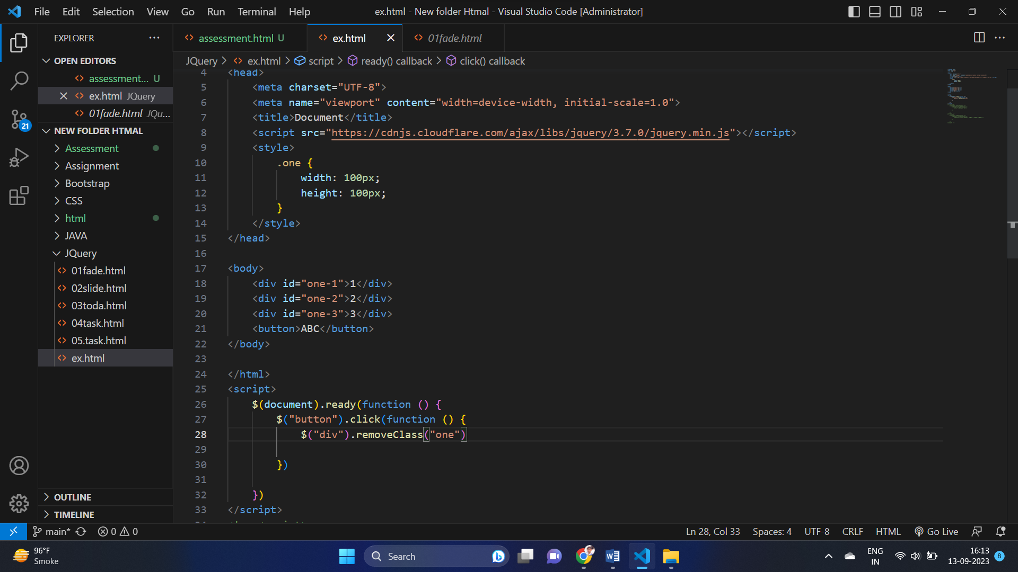

Animation

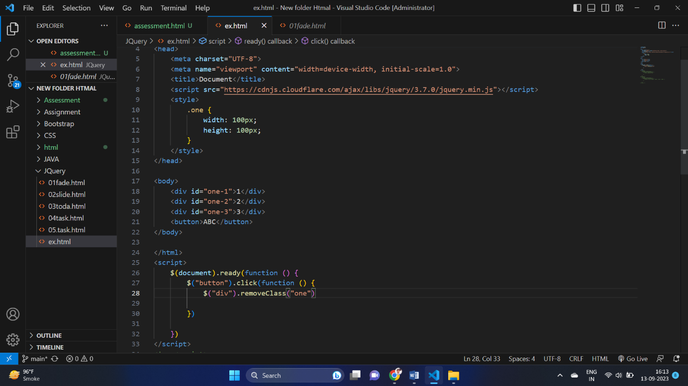

1. How to create slider with animation?

Ans 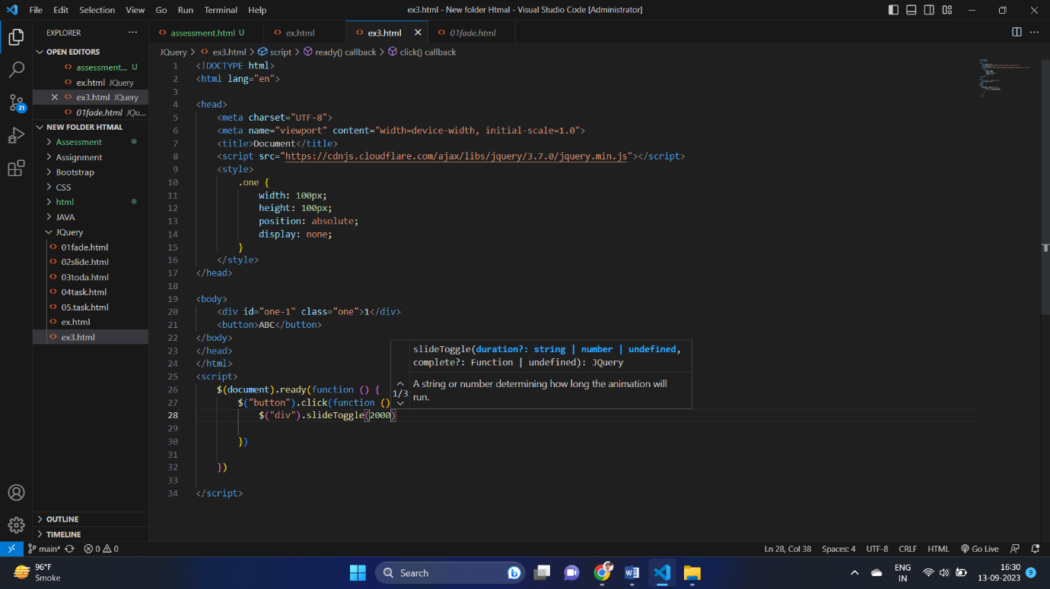

1. Event bubbling tickling example

Ans 